INOVA WEB APPLICATION TESTING PROCESS ATTR MODULE

1. Attr> Review Attendance Log:
The review daily attendance log report from date and to date filter options are not working. Please check.
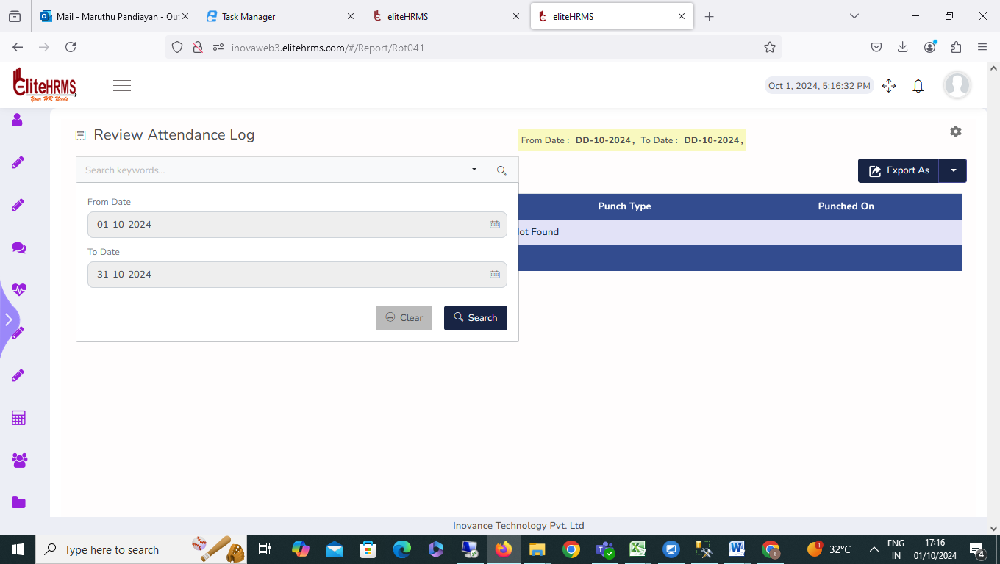

2. Attr> Review daily Attendance pdf:

The review daily attendance report has been clicked, and the application tab is automatically closed. Please check

3. Attr> Review daily Attendance:

- The review daily attendance report has been clicked, and the application tab is automatically closed. Please check
- The review daily attendance report in punch and out punch capture but attendance report status is absent only showed, please check.
- 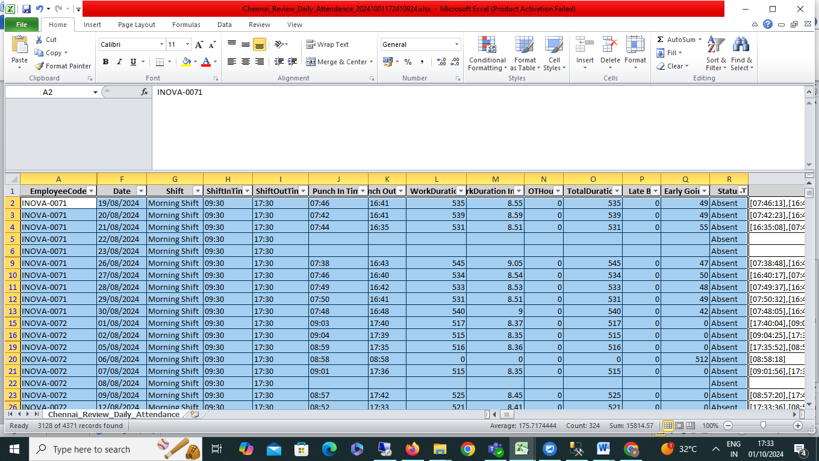

3. Attr>Muster roll:

The review Muster roll report has been clicked, and the application is automatically closed. Please check

4. Attr> Review Monthly Status:

The review monthly status report excel export options are not working. Please check

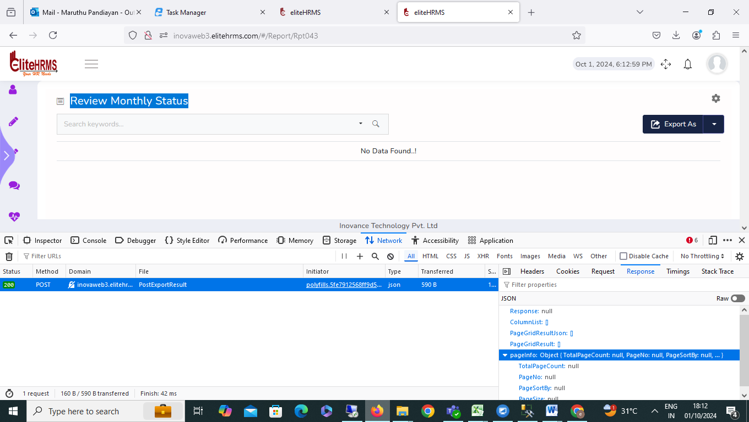
5. Attr> Review Monthly Summary:

The review Monthly Summary excels export options are not working. Please check
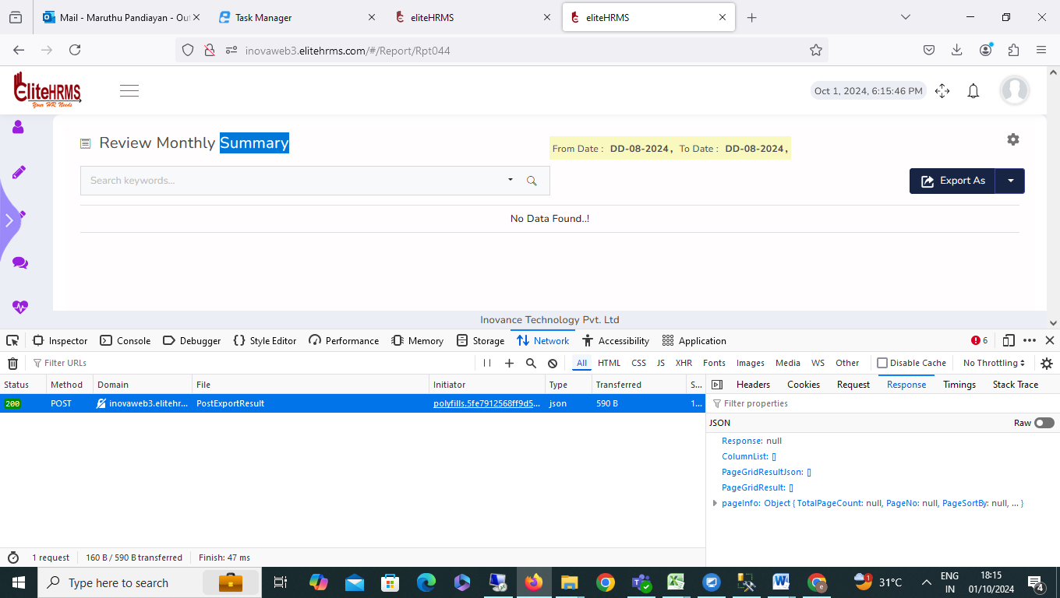

6. Attr> Review Monthly Present Summary:

The review Monthly Present Summary excels export options are not working. Please check
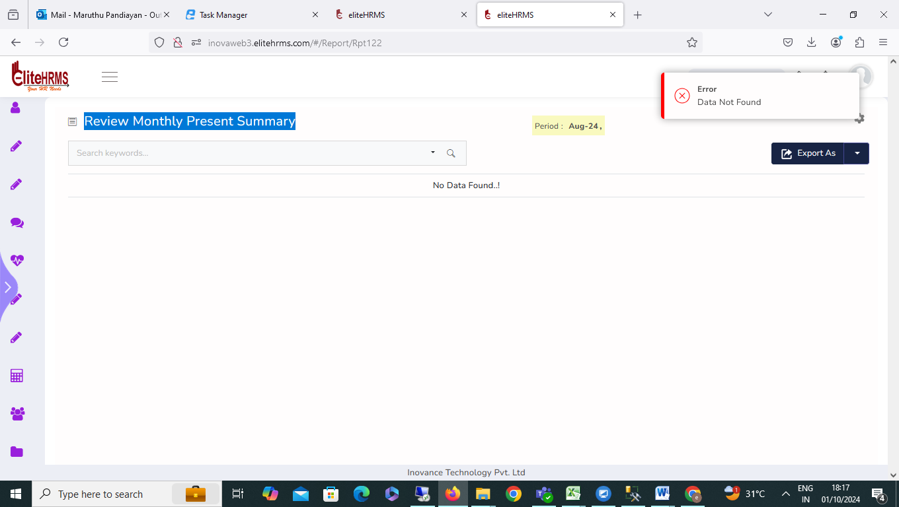

7.Attr> Review Attendance Rules:
The Review Attendance Rules is available in the application. The Excel export report shows the error message. Please check.
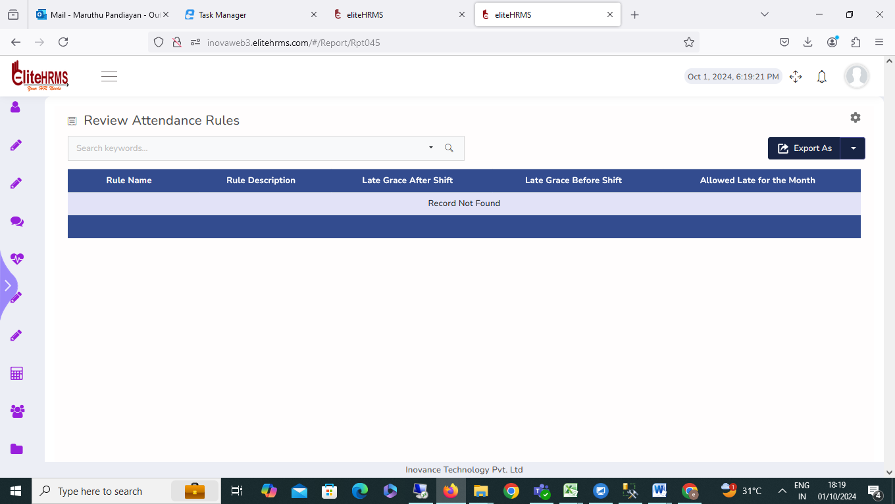

8. Attr> Review Shift:

The review shift display working hour, map attendance rule, and per-day working details are not visible; please check.
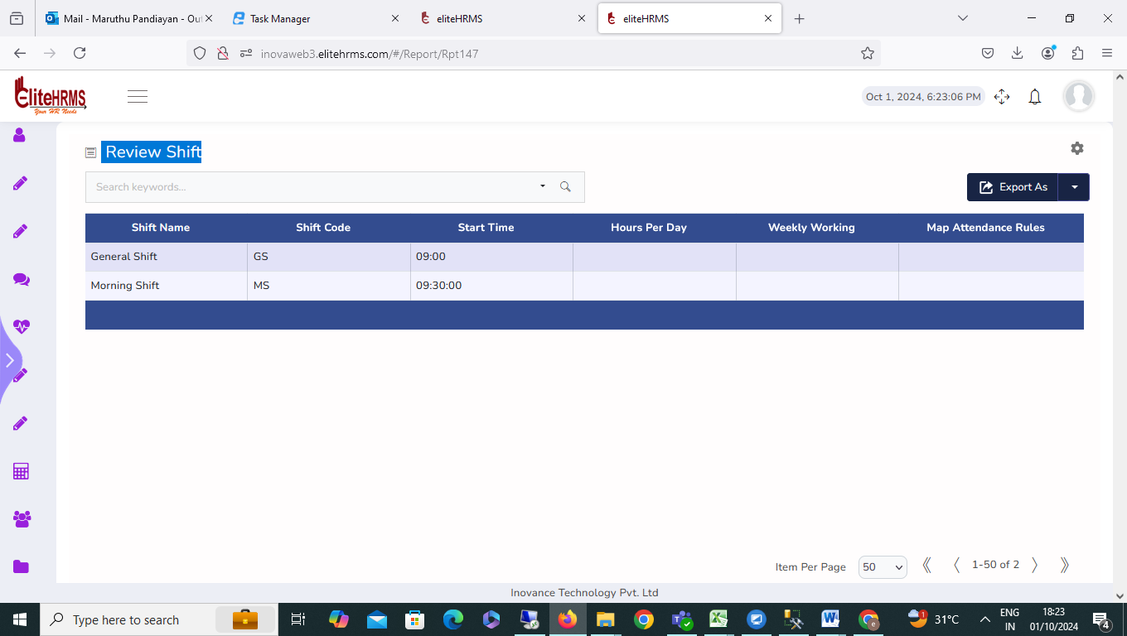

9. Attr>Review Shift Roster:
The Review Shift Roster details report working fine, no issue.

10.Attr> Review Map Employees;

The Review map Employees details report working fine, no issue.

11. Attr> Hourly On Duty:
The Hourly on Duty display Location, Department, Service Position, and On duty status are not visible; please check.

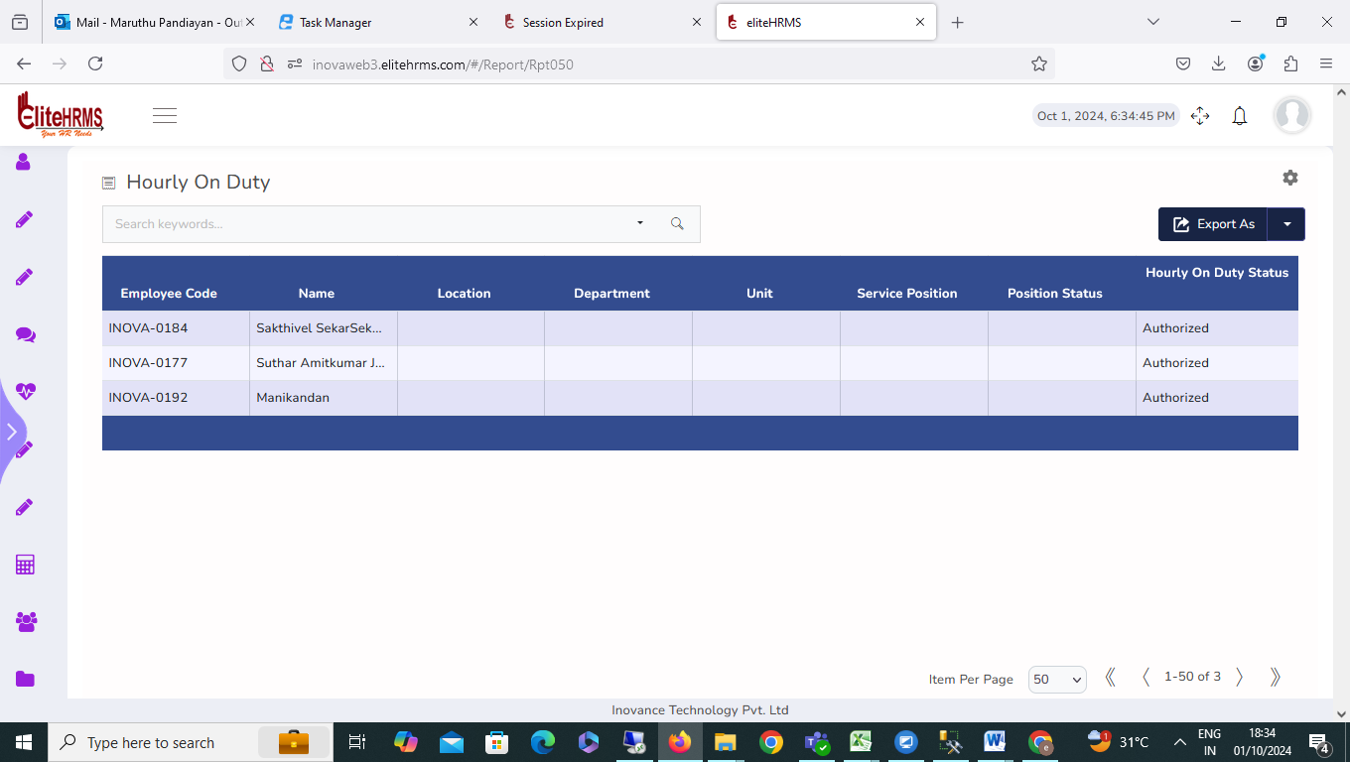

12.Attr> Review On Duty:

The On Duty display on duty status is not visible and from date and to date filters options not working; please check.
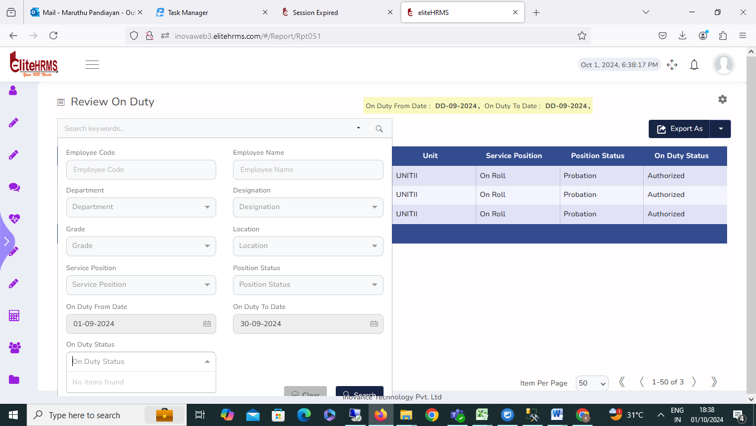

13.Attr> Review Attendance Register:

The Review Attendance Register report is not working; please check.
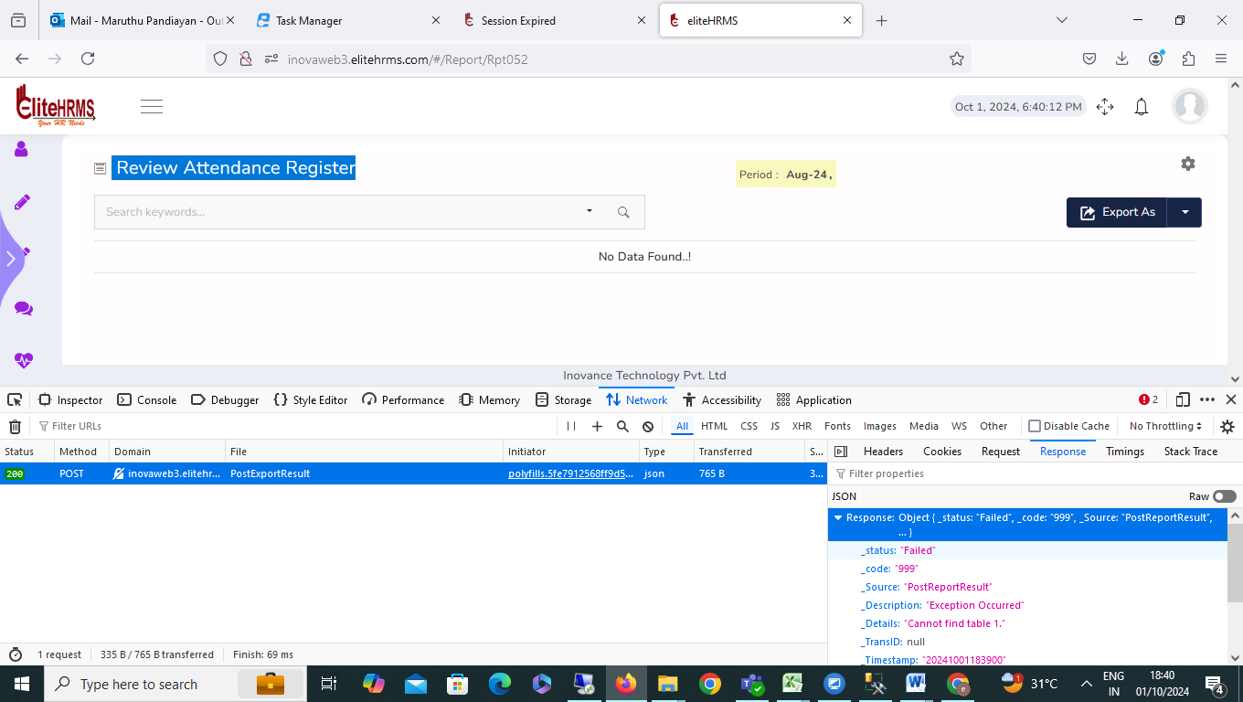

14,Attr> Review Attendance Leave:
The Review Attendance Leave report Leave type, Leave Status, from date and to date filter options are not working; please check.
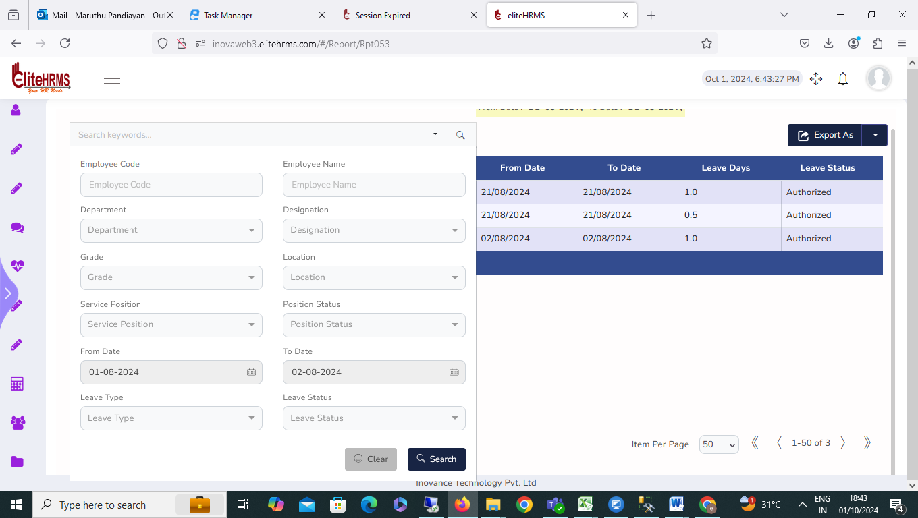

15. Attr> Shiftchange:
The Review Shiftchange is available in the application. The Excel export report shows the error message. Please check.
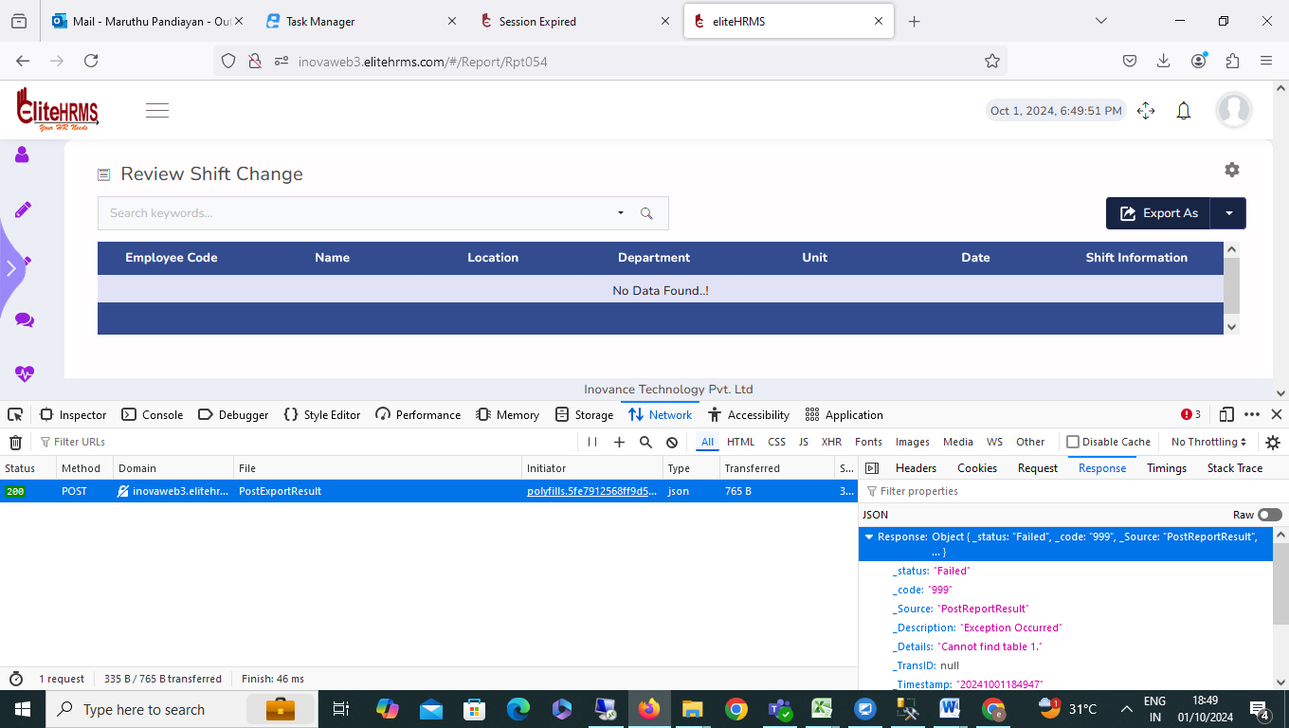

16. Attr> Review Geo Punch:

The Review Geo Punch display Employee Code Employee Name Shift Punch Time Punch Type and Location is not visible; please check.

\

